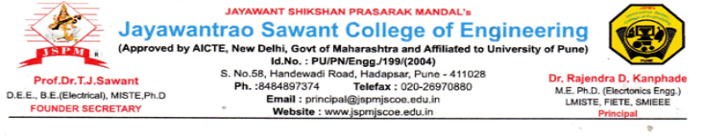

Date: 21/09/2023

**Sub: Smart India Hackathon 2023 – Nomination**

I am pleased to nominate the below team from our college to participate in Smart India Hackathon 2023.

AICTE AISHE code No for our college is C – 42216.

Team: TECH AVENGERS

|  |  |  |  |  |  |  |
| --- | --- | --- | --- | --- | --- | --- |
|  | Name | Gender (M/F) | Email id | Mobile No | Stream | Year |
| Team Leader | Shreyas  Aher | M | shreyasaher1534@gmail.com | 8308259965 | CSE | SE |
| Team Member | Avishkar  Bhusare | M | avishkarbhusare@gmail.com | 9309743471 | CSE | SE |
| Team Member | Vedanti  Patekar | F | vedantipatekar2004@gmail.com | 8308887498 | CSE | SE |
| Team Member | Shreya  Khadilkar | F | shreyayogeshkhadilkar@gmail.com | 8999201454 | CSE | SE |
| Team Member | Omkar  Dhumal | M | onkardhumal85@gmail.com | 9561295462 | CSE | SE |
| Team Member | Hariom  Pawar | M | hpmaratha123@gmail.com | 9766314543 | CSE | SE |

Sincerely,